**Project Design Phase**

**Problem – Solution Fit Template**

|  |  |
| --- | --- |
| Date | 15 February 2025 |
| Team ID | LTVIP2026TMIDS81651 |
| Project Name | Explore with AI: Custom Itineraries for Your Next Journey |
| Maximum Marks | 2 Marks |

**Problem–Solution Fit**

**I**n the context of *TravelGuideAI* means identifying real travel planning difficulties faced by users and providing an AI-powered itinerary solution that genuinely solves those issues. It ensures that the system is not just innovative, but also practical, useful, and aligned with user needs.

TravelGuideAI focuses on simplifying trip planning by generating personalized travel itineraries based on user inputs like destination, number of days, and preferences. The solution fits the problem by reducing planning time, confusion, and information overload.

Purpose

✅ Solve real travel planning challenges  
TravelGuideAI helps users who struggle with deciding where to go, what to do, and how to organize their trips efficiently.

✅ Improve solution adoption  
By providing instant AI-generated itineraries, users can quickly see value, increasing usage and trust in the platform.

✅ Enhance communication & engagement  
Clear recommendations, structured daily plans, and user-friendly design make the experience simple and engaging.

✅ Increase user touchpoints  
Frequent travelers can reuse the platform for multiple trips, creating continuous engagement and loyalty.

✅ Understand and improve user experience  
By analyzing user inputs and preferences, TravelGuideAI continuously provides more relevant and personalized suggestions.

**Template:**

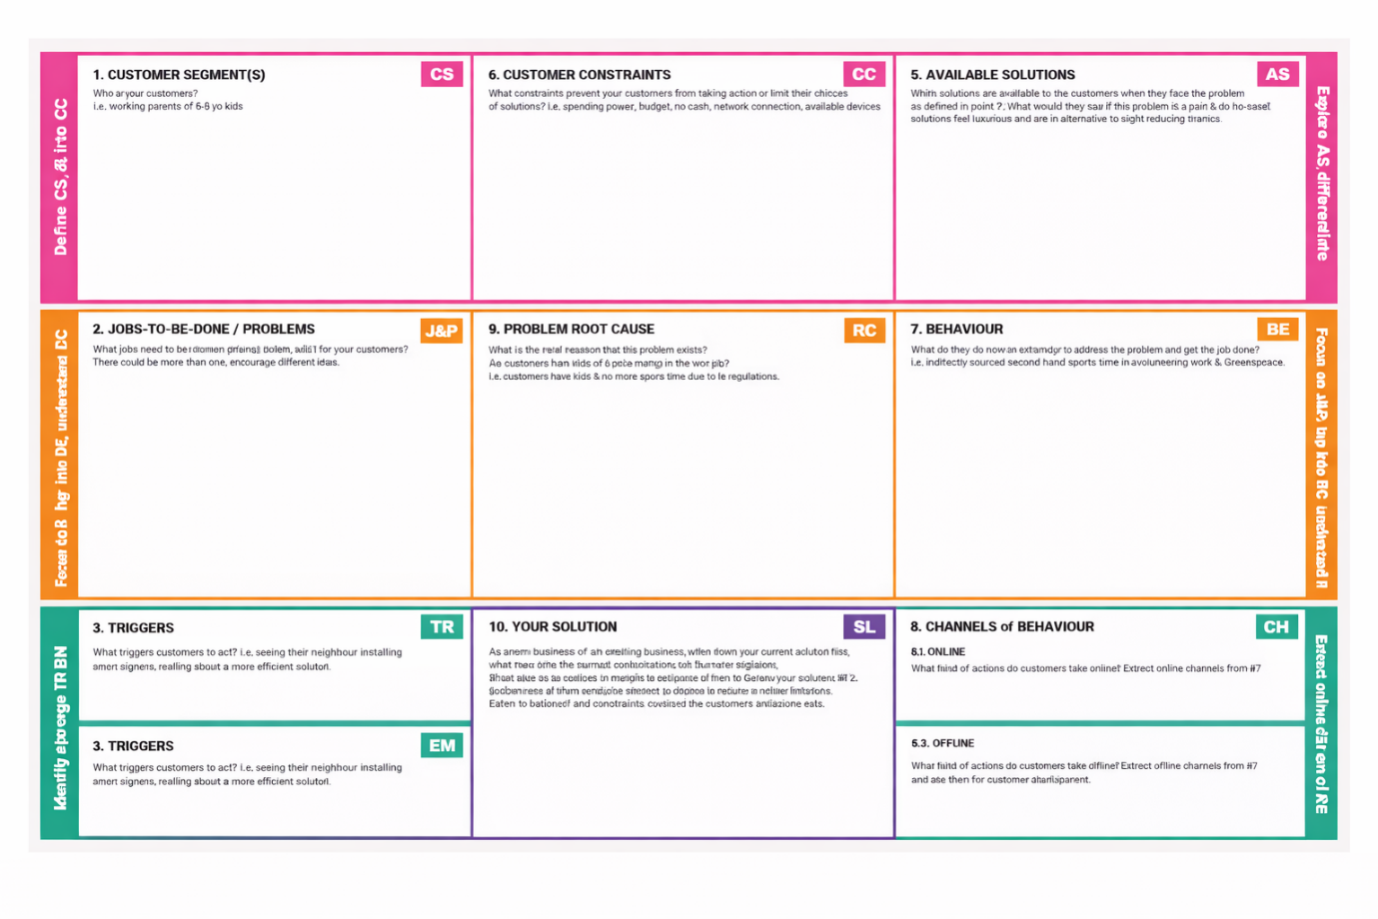

References:

1. <https://www.ideahackers.network/problem-solution-fit-canvas/>
2. <https://medium.com/@epicantus/problem-solution-fit-canvas-aa3dd59cb4fe>